

Table of content

|  |
| --- |
| Executive Summary |
| Introduction |
| Approach |
| Data Preparation and Exploratory Data Analysis (EDA) |
| Model Development and Evaluation |
| Solution Recommendation |
| Technical Recommendations |
| References |

***Executive Summary:***

The aim is to identify Australian primary school students who may face challenges with numeracy, based on their early reading and math skills in Years 1 and 2. The analysis utilizes data from 2,000 students across 40 schools, gathered between 2016 and 2020. A student’s risk status was assessed based on their Year 3 NAPLAN results **(ACARA, 2020).**

Logistic regression was used due to its ability to clearly indicate which skills are most important, such as Numeracy and Literacy. Although this had 81% accuracy and 70% precision, it failed to identify some students at risk, resulting in a low recall rate. This approach aligns with the call for interpretable models in educational analytics **(Azodi et al., 2020**).

The K-Nearest Neighbours model found more at-risk students but was less precise. Clustering was used to group students by their literacy levels, helping in support programs. These models support the practical application of learning analytics in schools while raising important ethical considerations **(Slade, Prinsloo, & Khalil, 2019).**

Key stakeholders are Data2Intel, which needs clear insights; schools, who provide early support; and education policymakers, who allocate resources.

**Recommendation:**  
Schools focus on skill-based support programs, Data2Intel improves the model by adding more student info like socio-economic background (**DESE, 2021**), and policymakers use cluster insights to plan resources.

**Future Work:**  
Logistic regression provides reliable and visible results; however, investigating other complex algorithms such as Random Forest or Gradient Boosting might more effectively pinpoint additional students in need of early assistance. Future efforts should concentrate on collecting diverse data and retraining models on a regular basis **(Wiliam, 2011; Strickland, Woods, & Pavlovic, 2016).**

***BACCM***

**Need:**  
Australian primary schools and education stakeholders require a dependable method to identify students at risk of numeracy challenges early on, using formative assessment data from Years 1 and 2 **(Wiliam, 2011**). It’s important to assess a large group of 2,000 students using 34 different attributes. This comprehensive data helps create accurate predictions for future at-risk students.

**Solution:**  
A dataset of 2,000 students from 40+ schools (2016–2020) was analysed using logistic regression, K-Nearest Neighbours, and clustering to predict Year 3 numeracy risk from early literacy and numeracy skills, providing actionable intervention insights **(ACARA, 2020; DESE, 2021).**

**Value:**  
The analysis allows schools to more effectively target interventions, reduces the number of at-risk students who are missed, and aids policymakers in efficient resource allocation. Data2Intel enhances its predictive capabilities to assist educational services in making evidence-based decisions **(Slade et al., 2019).**

**Change:**  
Schools and policymakers will shift to data-driven early identification and targeted support programs based on model predictions and clustering of student literacy levels, moving away from reactive to proactive student support **(Strickland et al., 2016**).

**Stakeholders:**

* **Data2Intel:** Utilizes predictive insights to create improved support tools and reports.
* **Schools:** Execute early measures for students identified as at risk.
* **Education Policymakers:** Develop funding strategies and programs based on cluster and risk group categorizations.

**Context:**  
This project utilizes detailed formative assessment data, validated by NAPLAN results, to identify numeracy risks in early primary school years. It meets the need for practical analytics aimed at enhancing literacy and numeracy outcomes in Australian primary education **(ACARA, 2020; DESE, 2021).**

***Approach:***

two supervised models, K-Nearest Neighbours (KNN) and Logistic Regression has been used, to identify students at risk based on their early numeracy and literacy skills. Logistic Regression achieved 81% accuracy by focusing on important skills like Place Value and Addition & Subtraction, while KNN boosted the ability to catch more at-risk students, improving recall to 77%, by comparing students with similar learning profiles **(Azodi et al., 2020).**

Clustering, an unsupervised model, was used to group students based mainly on their TextLevel-02-SOY and TextLevel-02-EOY literacy scores, creating distinct clusters that reveal different risk profiles. This helped identify high-risk and lower-risk student groups, supporting targeted intervention strategies **(Slade et al., 2019).**

***Data Overview and Preprocessing***

The dataset includes information on 2,000 students with 34 attributes, used to identify those at risk of numeracy difficulties.

***Numerical Features:***

* TextLevel-(01-SOY, 01-MOY, 01-EOY, 02-SOY, 02-MOY, 02-EOY)
* WritingVocab-01-SOY, HRSIW-01-SOY
* Counting-(01, 02)
* Place Value-(01, 02)
* Addition and Subtraction-(01, 02)
* Multiplication and Division-(01, 02)
* Kinder_Age
* NumSibling
* SiblingOrder
* SES-(01, 02)
* NumAbvYear9, NumAbvDiploma, NumProf
* Year_02

***Categorical Features*:**

* Gender
* Disability-(Non-disable, Cognitive, Physical, Sensory, SocialEmotional)
* NCCD-Funded
* At_Risk_Numeracy (Target Variable)

***Data Quality-Assessment***

**Missing Values:**

* There are **0 missing/null values** across all **2,000 students and 34 attributes**, so no imputation was needed.

**Outliers Detected**

* **Outliers were identified** in several features: for example, over **15 students** had TextLevel-01-SOY scores above 30, and around **20 students** showed unusually high Writing Vocabulary counts beyond 80 words

**Preprocessing Steps:**

* **Feature Encoding:**  
  The target feature Numeracy_At_Risk was converted to numeric values to enable accurate analysis, and the Gender feature was also encoded numerically to facilitate clearer insights.

***Univariate Analysis***

***Kinder_Age***

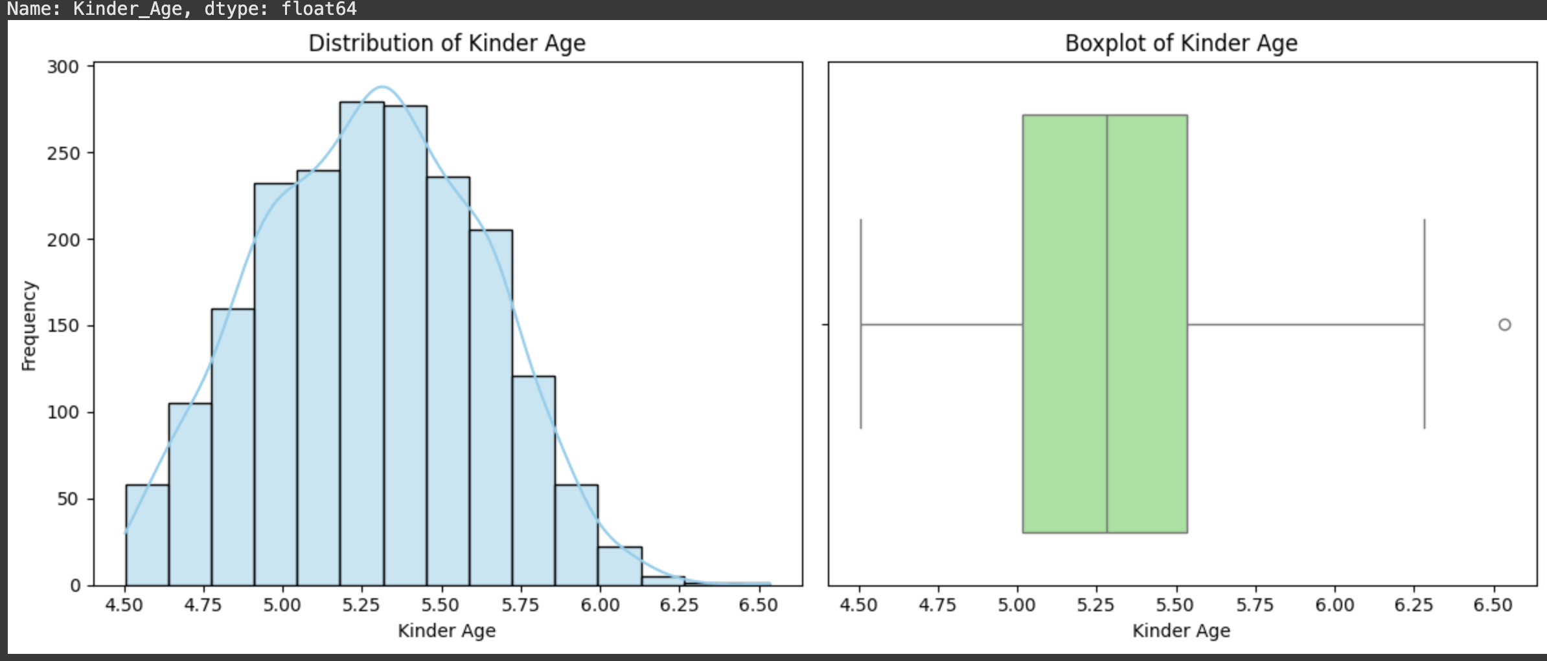

**EDA**

Age ranges from 4.5 to 6.5 years with a right skew and a few outliers above 6.25. Most students are between 5.0 and 5.5 years.

**Insights:**

Most started kindergarten at the typical age of 5.0 to 5.5 years, with some delayed entries.

***Gender***

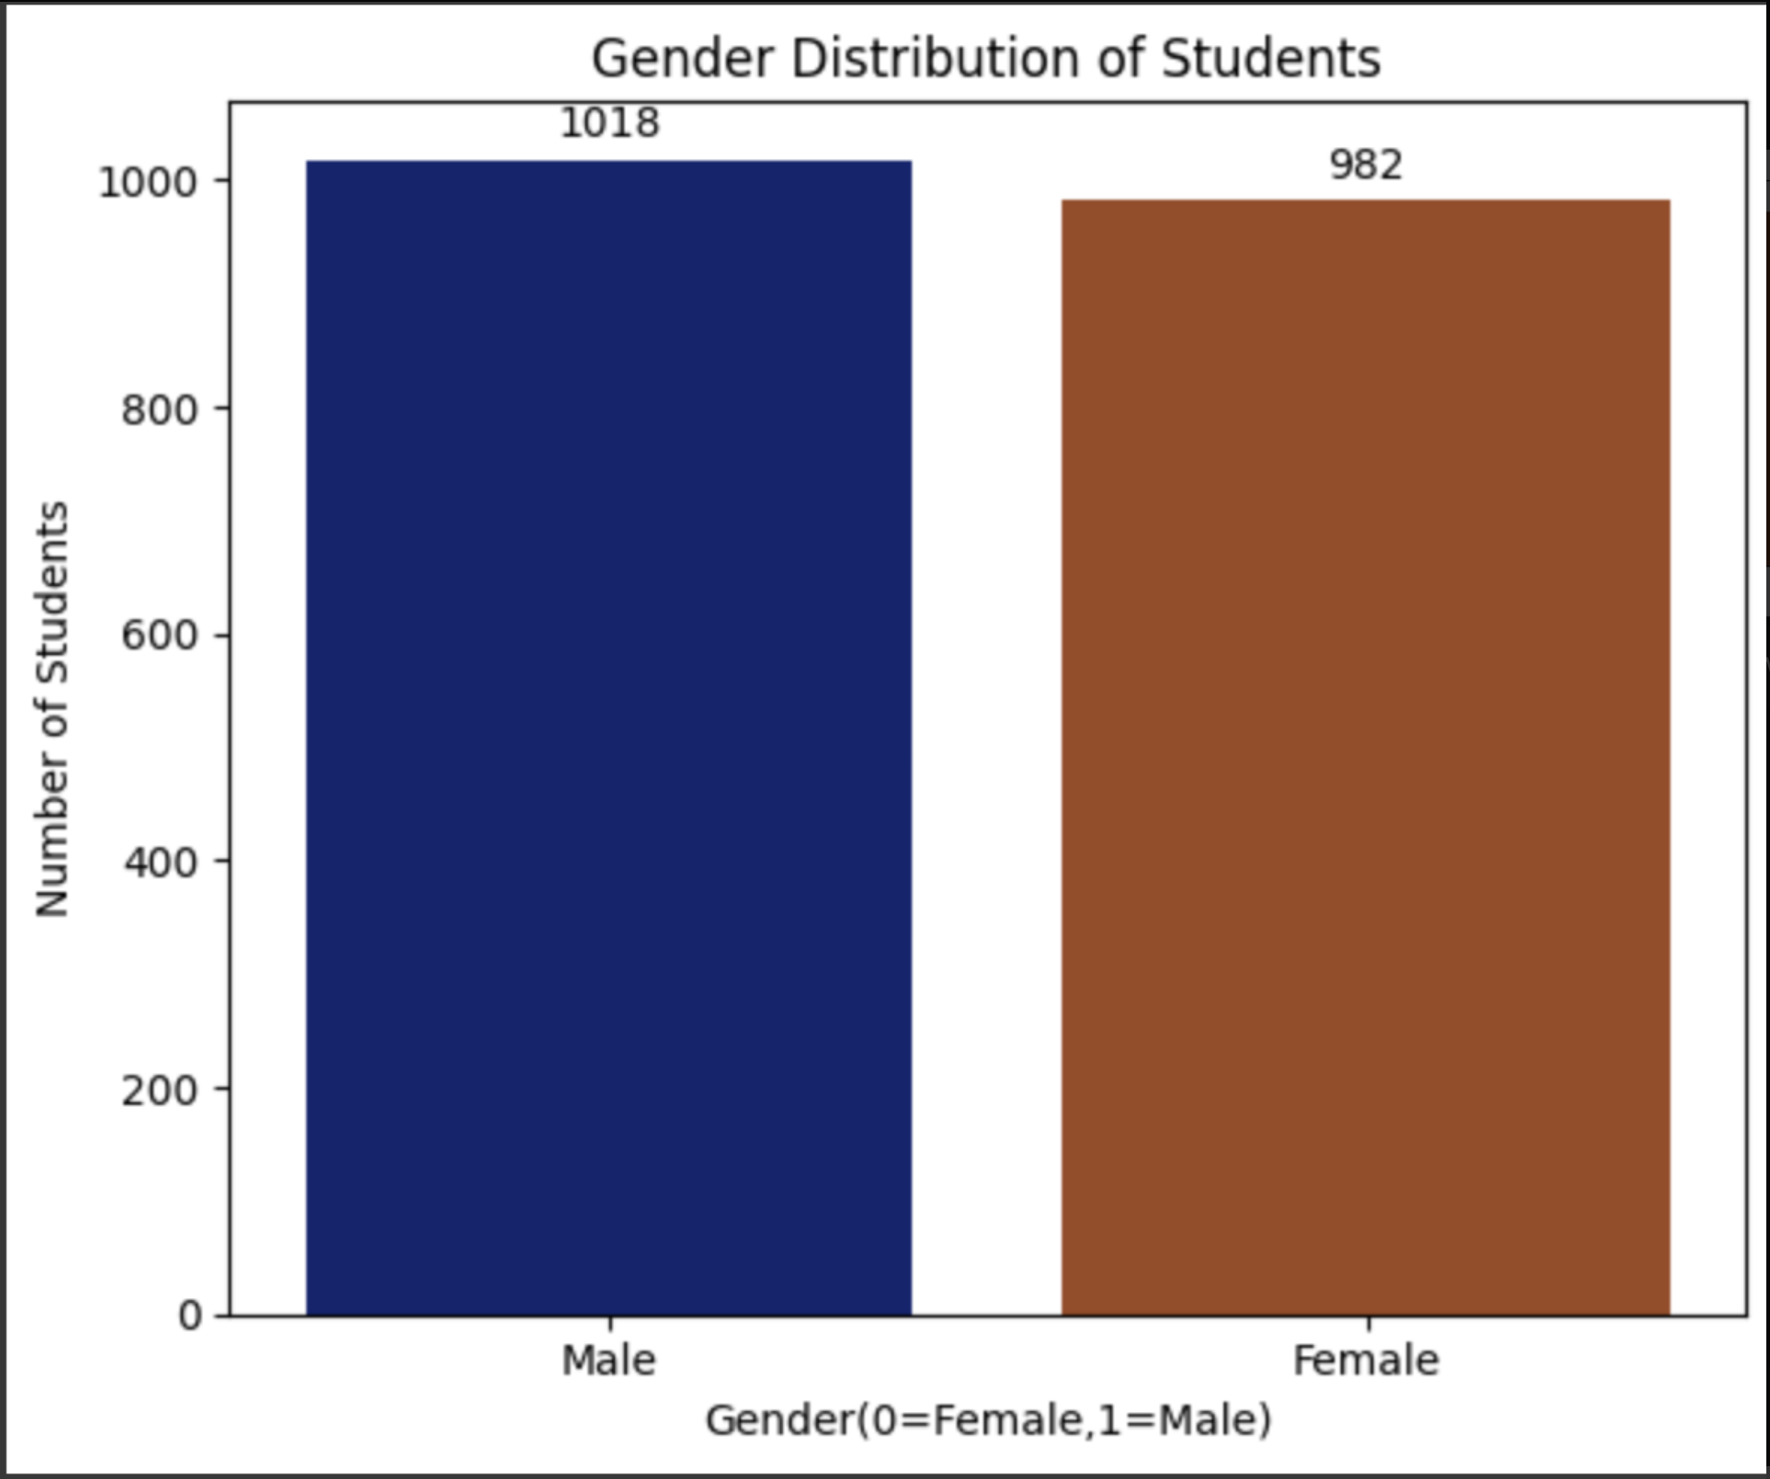

**EDA:**

* There are **1,018 male students** and **982 female students**.
* Males make up **50.9%** of the dataset, while females account for **49.1%**.

**Insights:**

* **Male students slightly outnumber female students** by just 36 individuals.

***Disability_Non-disable***

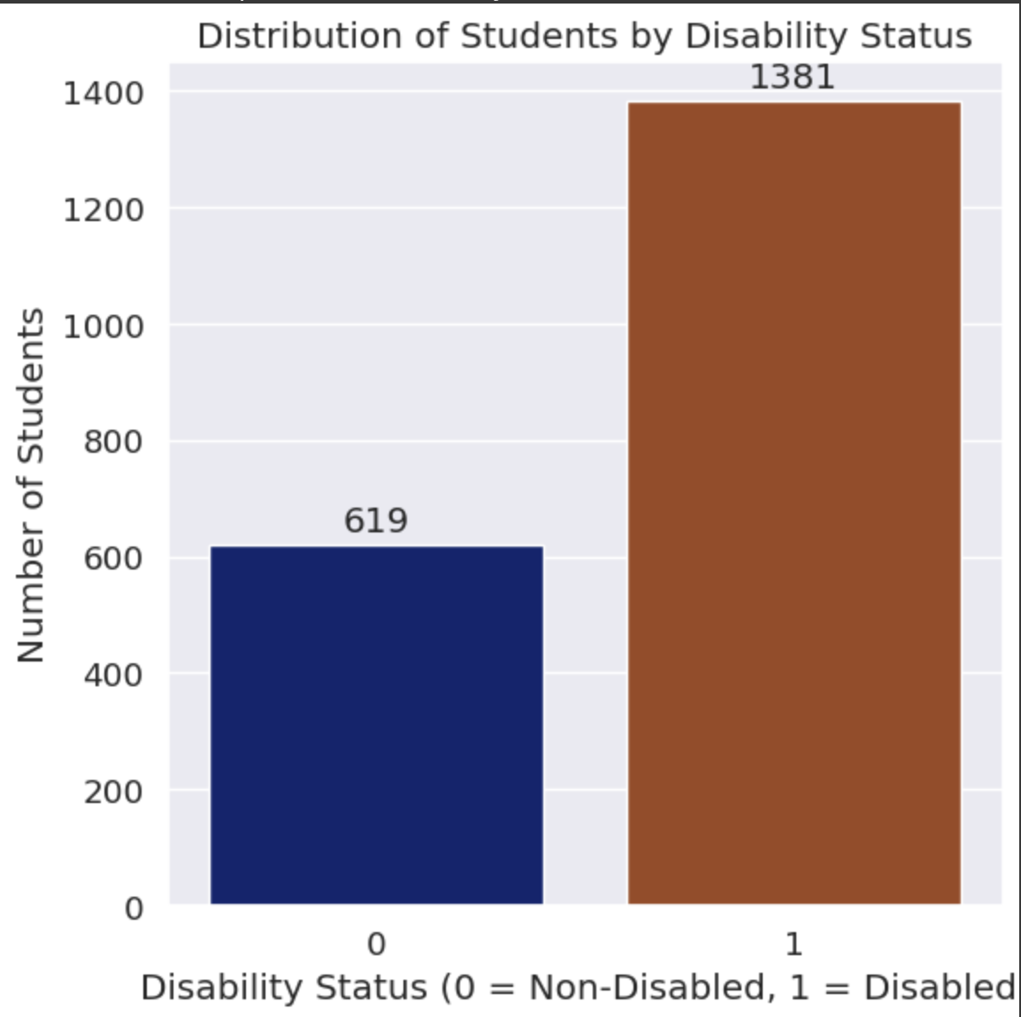

***EDA:***  
• 69% (1,381) of students are Disabled.  
• 31% (619) are Non-disabled.

***Insights:***  
• Most students are disabled, making up over two-thirds of the sample.  
• Non-disabled students form a smaller minority.

***Disability_Cognitive***

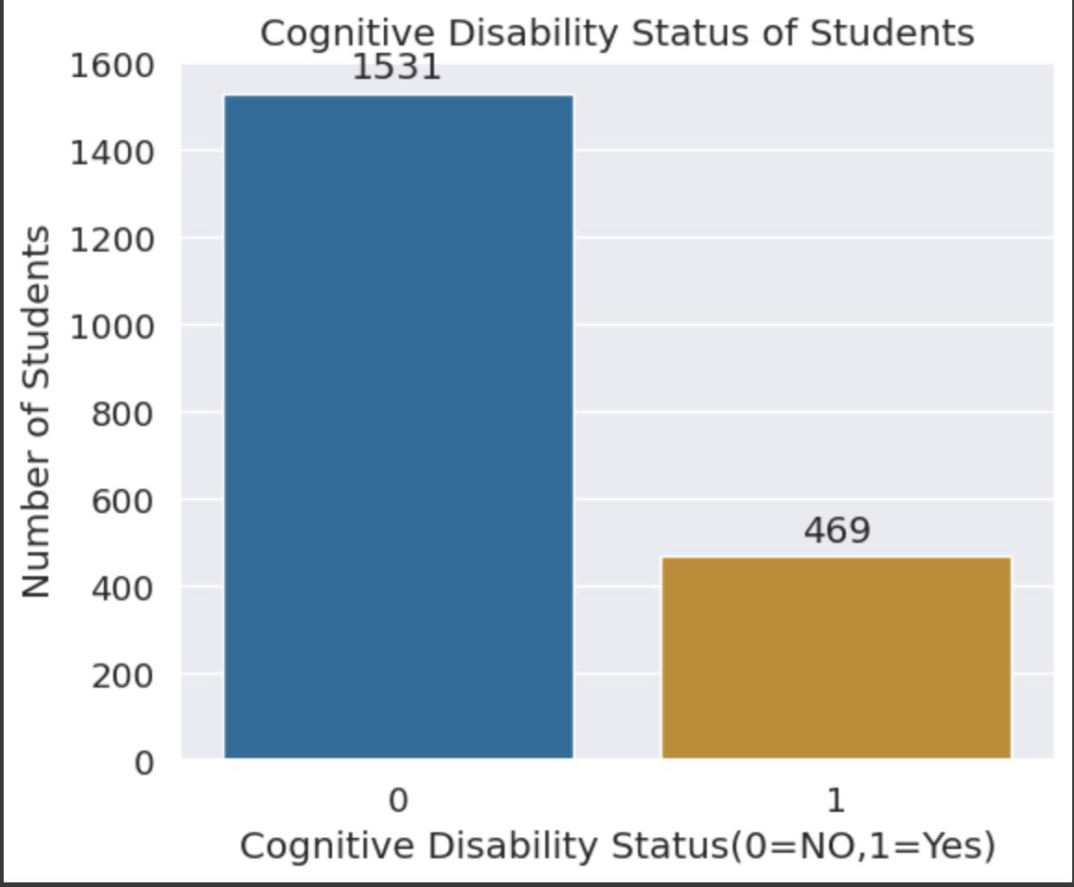

**EDA:**  
• 76.6% (1,531) of students are cognitively non-disabled.  
• 23.4% (469) have a cognitive disability.

**Insights:**  
• Most students do not have cognitive disabilities.  
• 1 in 4 students may need support, making it a key factor for numeracy risk.

Disability_Sensory

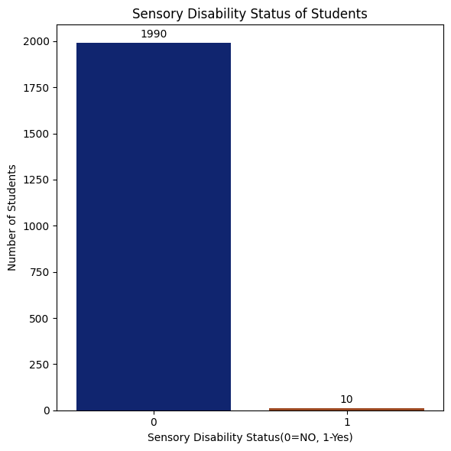

**EDA:**  
• 99.5% (1,990) have no sensory disability.  
• 0.5% (10) have a sensory disability.

**Insights:**  
• Sensory disabilities are rare.  
• Likely minimal impact on overall numeracy risk.

***Disability_SocialEmotional***

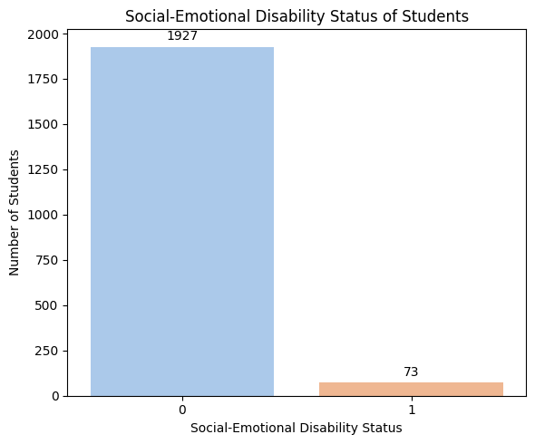

**EDA:**  
• 96.35% (1,927) have no social-emotional disability.  
• 3.65% (73) do have one.

**Insights:**  
• Social-emotional disabilities are uncommon.  
• Most students are unaffected.

***NCCD-Funded***

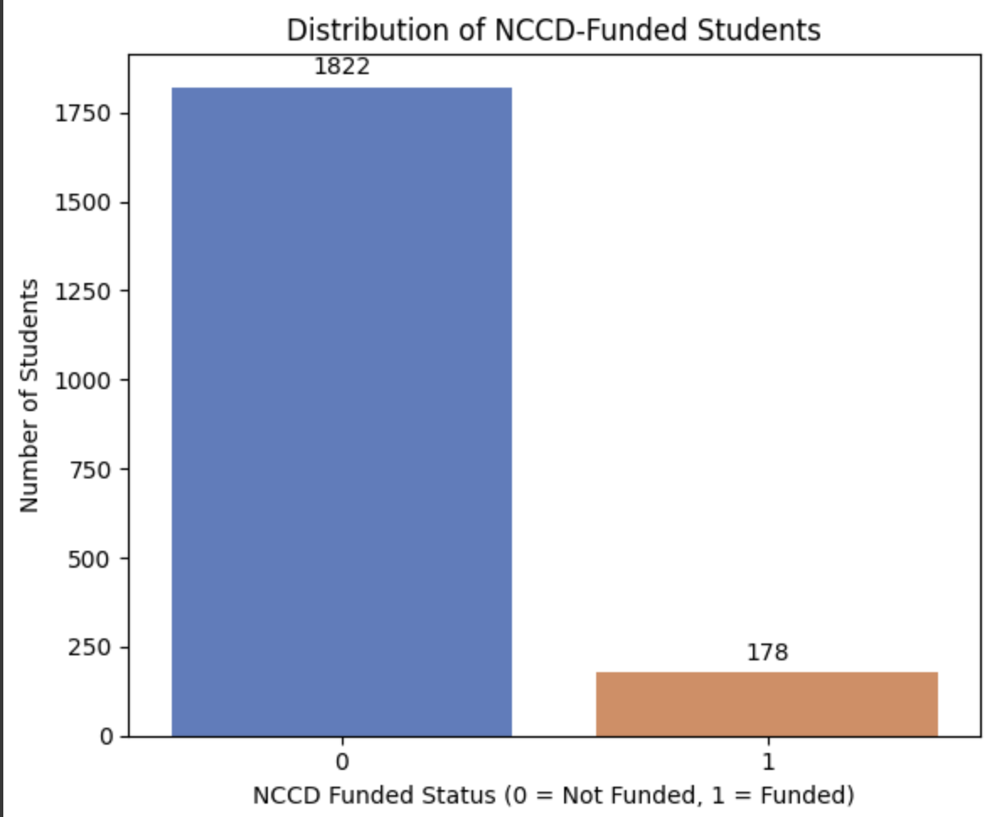

**EDA:**  
• 8.9% (178) are NCCD-funded.  
• 91.1% (1,822) are not.

**Insights:**  
• NCCD funding is limited to a small group.  
• Fewer than 1 in 10 students receive support.

***NumSibling***

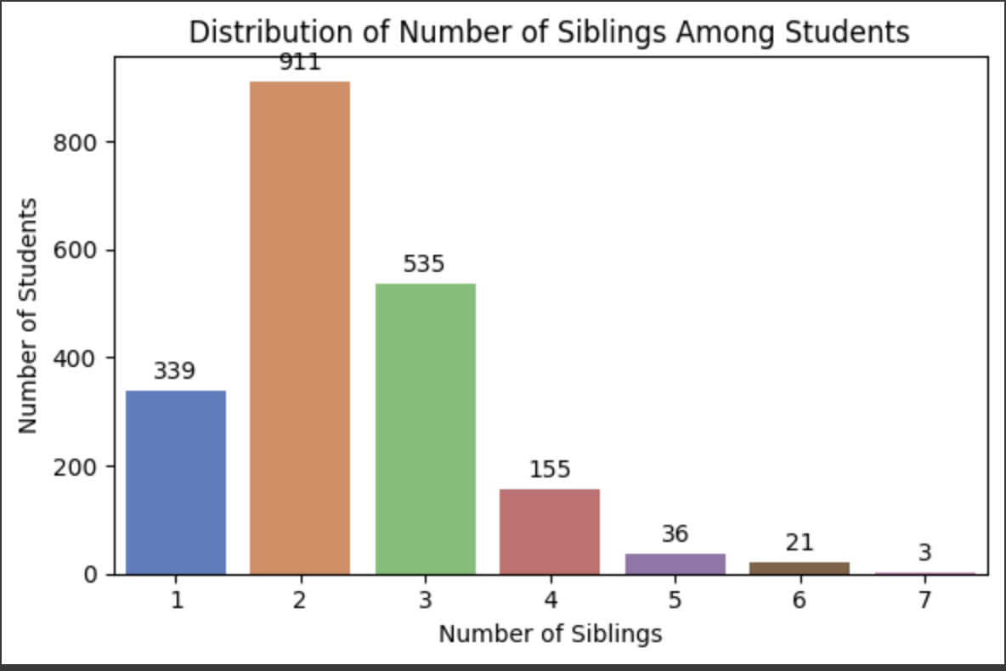

**EDA:**  
• Most students (45.6%) have 2 siblings.  
• 3 siblings: 535 students; 1 sibling: 339 students.  
• 5+ siblings are rare (60 students total).

**Insights:**  
• Small to medium-sized families (1–3 siblings) are typical.  
• Large families are uncommon.

***SiblingOrder***

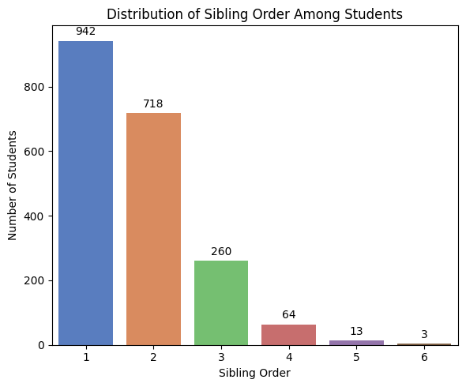

**EDA:**  
• Most students are first-born (942), followed by second-born (718).  
• Higher birth orders are less common.

**Insights:**  
• Over 80% are first or second-born.  
• 4th+ birth order is rare.

***Counting-01***

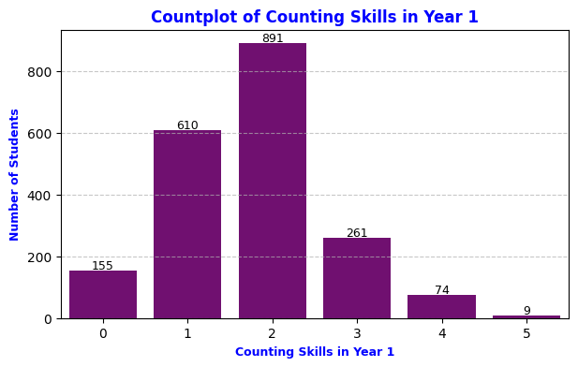

**EDA:**  
• Most students scored 2 (891) or 1 (610).  
• Fewer reached 3 (261), 4 (74), or 5 (9).  
• 155 students scored 0.

**Insights:**  
• Basic counting (scores 1–2) is common.  
• Few excelled or struggled at the extremes.

***Place Value-01***

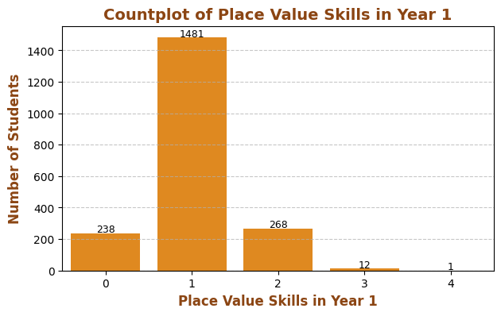

**EDA:**  
• Most students scored 1 (1,481).  
• Fewer scored 2 (268), 3–4, or 0 (238).

**Insights:**  
• Score 1 is most common, showing early place value skills.  
• Advanced scores are rare.

***Addition and Subtraction-01***

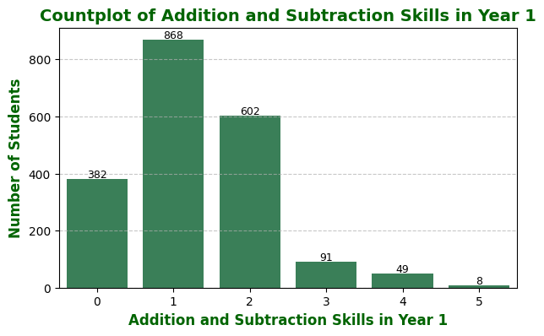

**EDA:**• Most students scored 1 (868) or 2 (602).  
• 382 scored 0; few reached 3–5 (148 total).

**Insights:**  
• Early-stage addition/subtraction skills are common.  
• Few show advanced proficiency.

***Multiplication and Division-01***

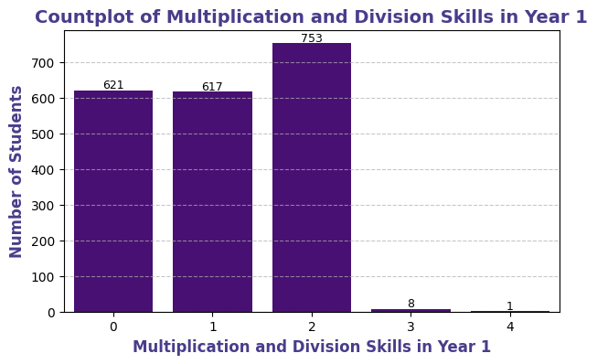

**EDA:**  
• Most scored 2 (753), followed by 0 (621) and 1 (617).  
• Only 9 students reached advanced levels.

**Insights:**  
• Multiplication/division skills are still developing.  
• Advanced understanding is rare.

***TextLevel-01-SOY***

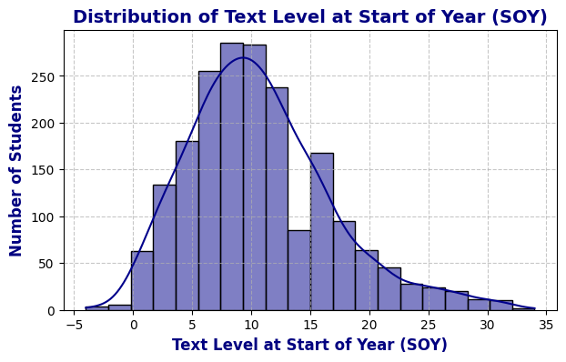

**EDA:**  
• Scores cluster between 5–15, peaking near 10.  
• Right-skewed with few outliers above 25.

**Insights:**  
• Most start with basic reading levels.  
• Few students show advanced literacy early on.

***TextLevel-01-MOY***

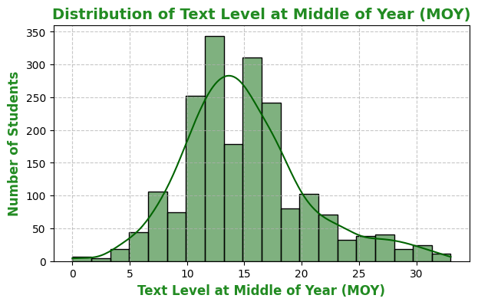

**EDA:**  
• Scores cluster between 10–20, especially around 13–15.  
• About 40 students scored 25+.

**Insights:**  
• Most have mid-level reading skills.  
• Few show advanced text-level ability.

***TextLevel-01-EOY***

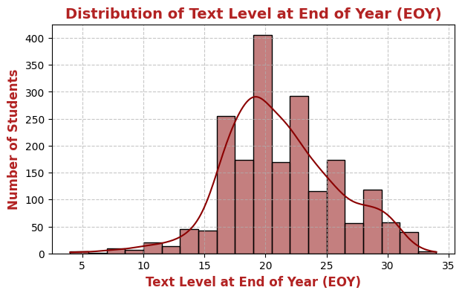

**EDA:**  
• Text level 20 is most common.  
• Majority fall within 15–25 range.

**Insights:**  
• Most show strong year-end reading progress.  
• Few reach above 30, showing high proficiency.

***WritingVocab-01-SOY***

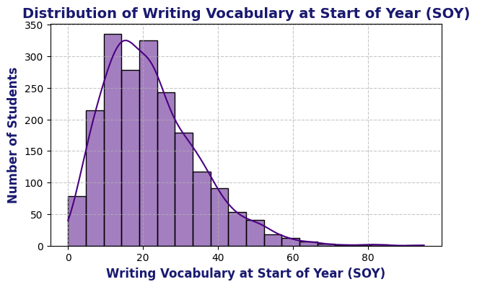

***EDA:***  
• Most students knew 10–30 words, peaking at 10–20.  
• Sharp drop after 40 words.

***Insights:***  
• Majority started with basic vocabulary.  
• Few began with 50+ words, showing early advantage.

***HRSIW-01-SOY***

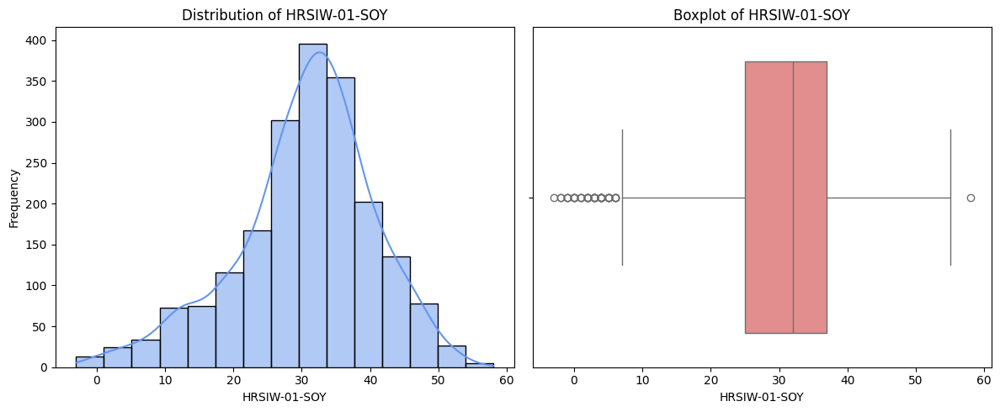

**EDA:**  
• Most scores fall between 25–40, with a median around 32–35.  
• Few outliers below 10 and near 58.

**Insights:**  
• Majority perform in the mid-range.  
• Only a few are very low or high scorers.

***Multivariate Analysis***

Year 1 Numeracy Skills Vs At-Risk_Numeracy

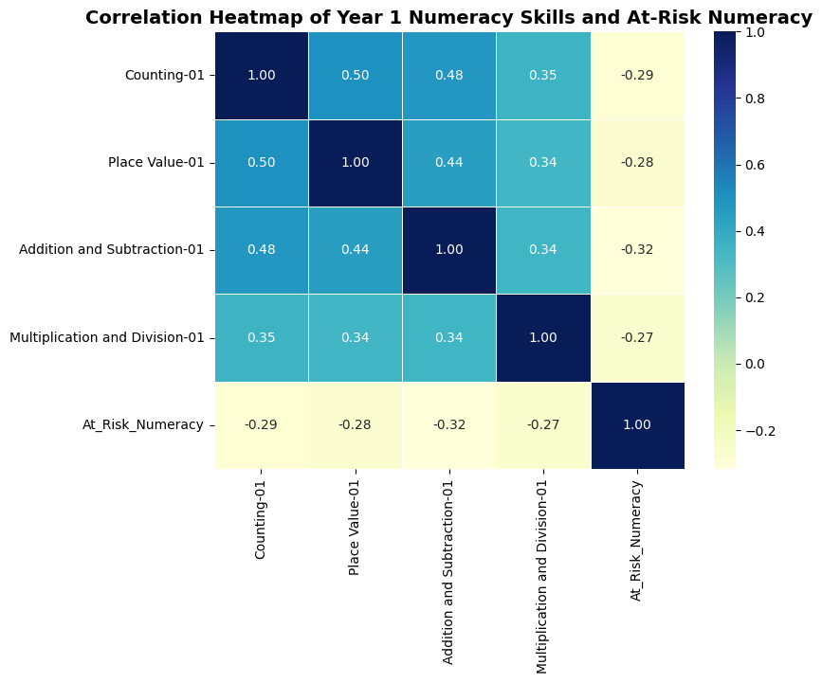

***EDA:***  
• Addition/Subtraction-01 where r = -0.32 and Counting-01(-0.29) show moderate negative correlations with numeracy risk.

***Insights:***  
• Strong early math skills reduce numeracy risk.  
• Counting is also a key protective factor.

Reading Skills Vs At-Risk_Numeracy

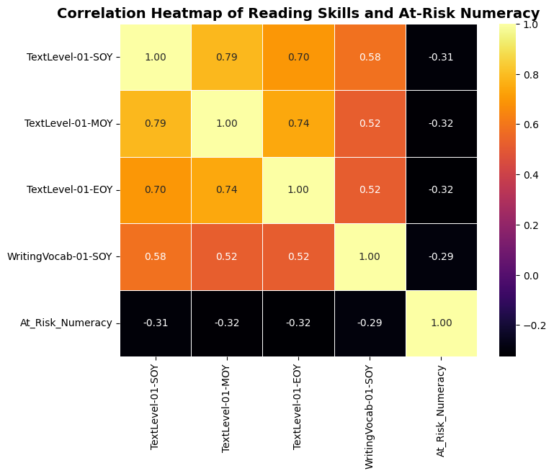

***EDA:***  
• TextLevel-SOY, MOY, and EOY all show r = -0.32 with numeracy risk.

***Insights:***  
• Better reading skills link to lower numeracy risk.

.

Year 1 Literacy vs Numeracy

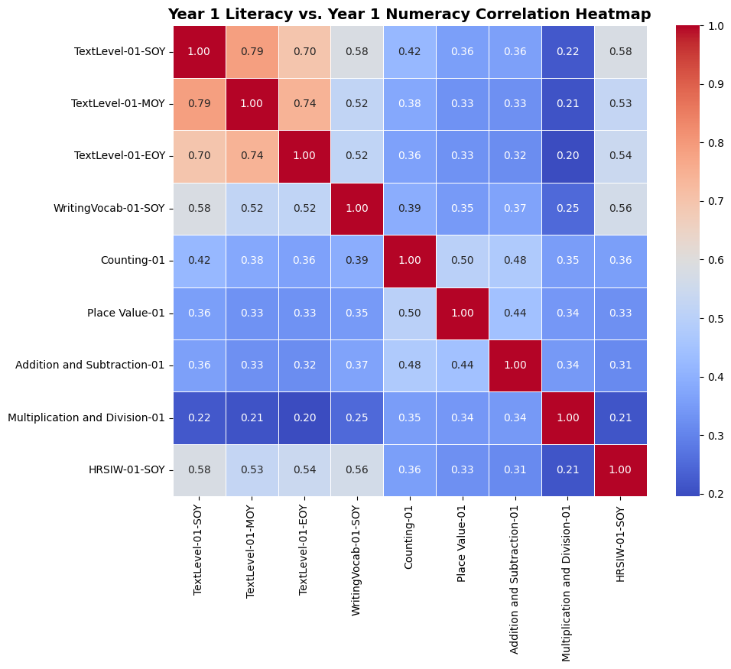

***EDA:***  
• TextLevel-01-SOY correlates with Counting-01 where r= 0.42 and HRSIW(r = 0.58).  
• WritingVocab links to Counting (r = 0.39) and HRSIW (r = 0.56).

***Insights:***  
• Strong early literacy supports counting skills.  
• HRSIW is a key indicator of early academic ability

Year 2 Literacy vs Numeracy

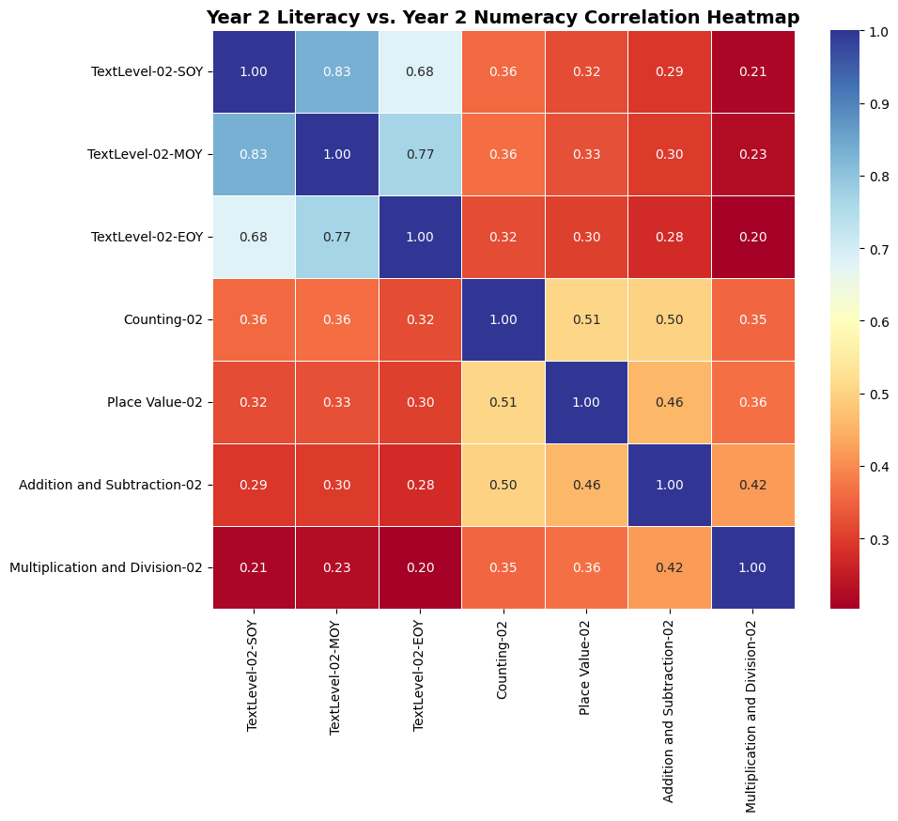

***EDA:***  
• Literacy–numeracy links are weak to moderate (e.g., r = 0.36).  
• Core numeracy skills (e.g., counting & place value) are strongly linked (r = 0.51).

***Insights:***  
• Reading and math skills diverge over time.  
• Core number skills remain closely connected.

Year 1, Year 2 Numeracy Literacy vs At-Risk Numeracy

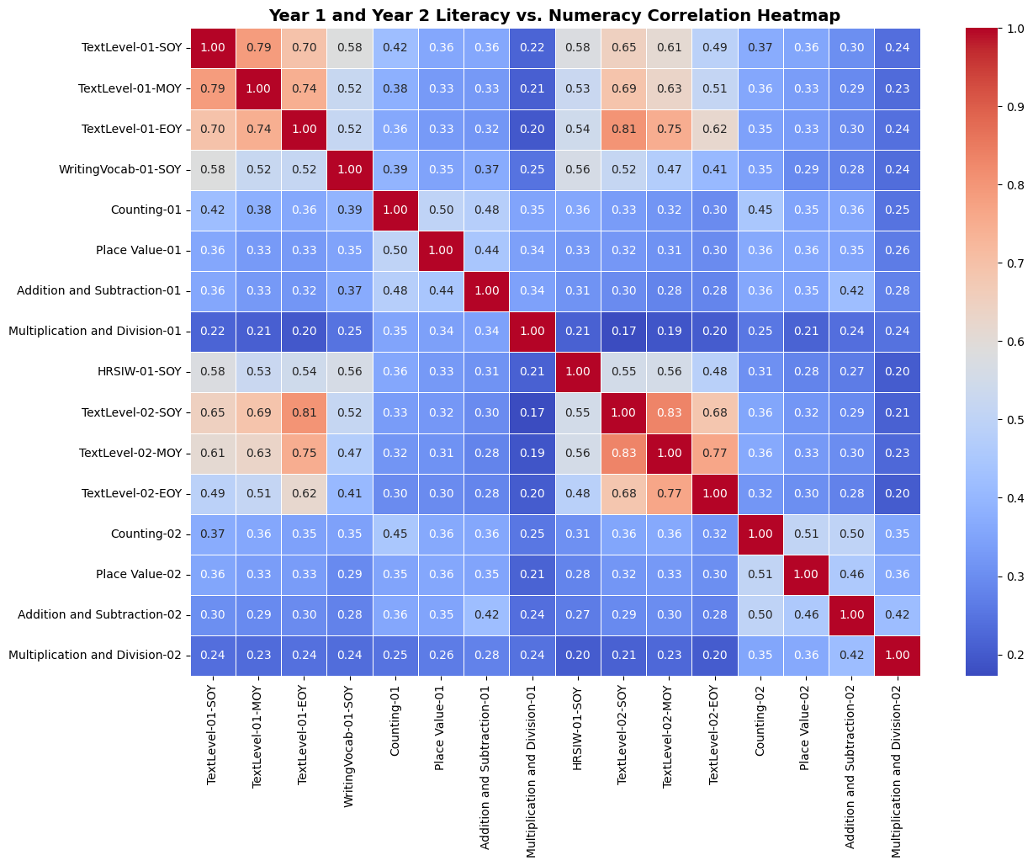

***EDA:***  
• TextLevel EOY (Y1) and SOY (Y2) are strongly correlated (r = 0.81).  
• Year 1 and 2 numeracy skills show moderate links (0.50).

***Insights:***  
• Reading progresses steadily across years.  
• Literacy–numeracy connection is moderate.

Literacy , Numeracy VS At_Risk

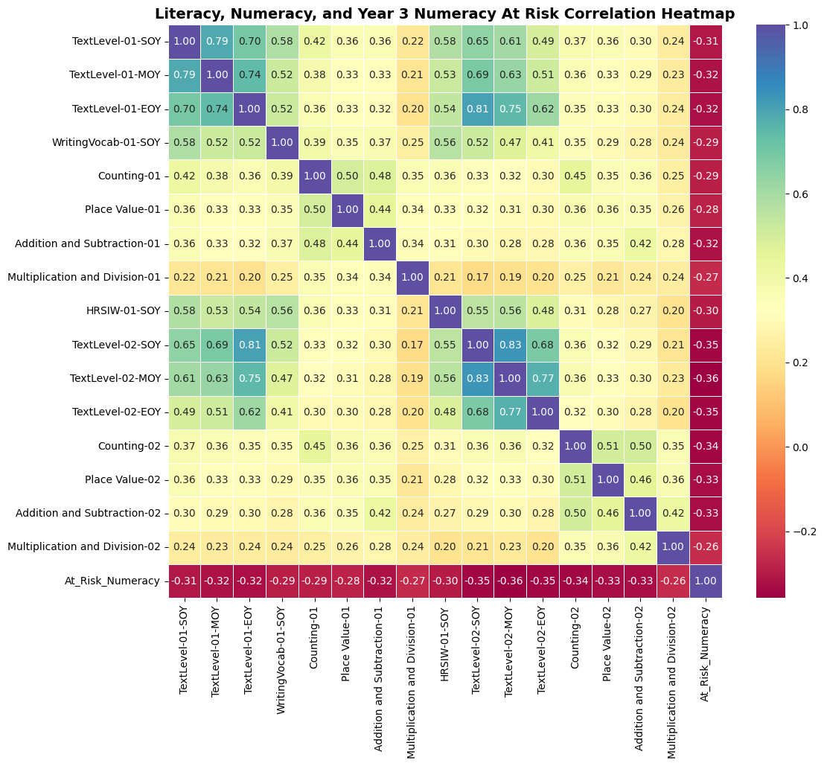

**EDA:**  
• Year 2 reading (r ≈ -0.36) and numeracy (r ≈ -0.33) show moderate negative correlation with numeracy risk.

**Insights:**  
• Strong Year 2 skills reduce Year 3 numeracy risk.

Disability Features vs Numeracy

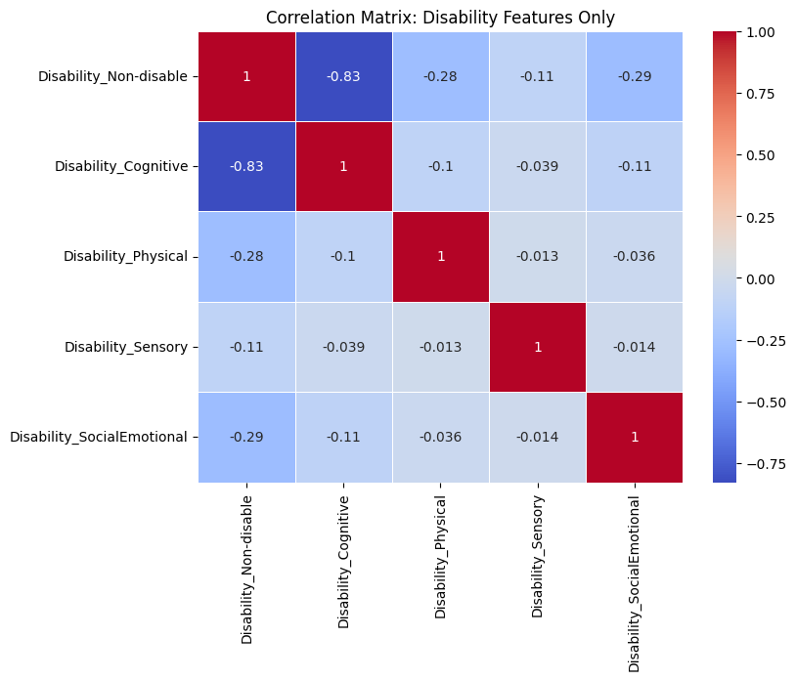

**EDA:**  
• Non-disable vs. Cognitive Disability shows strong negative correlation (-0.83).  
• Other disability types have weak correlations (-0.01 to -0.29).

**Insights:**  
• Disability types are mostly independent and rarely overlap.

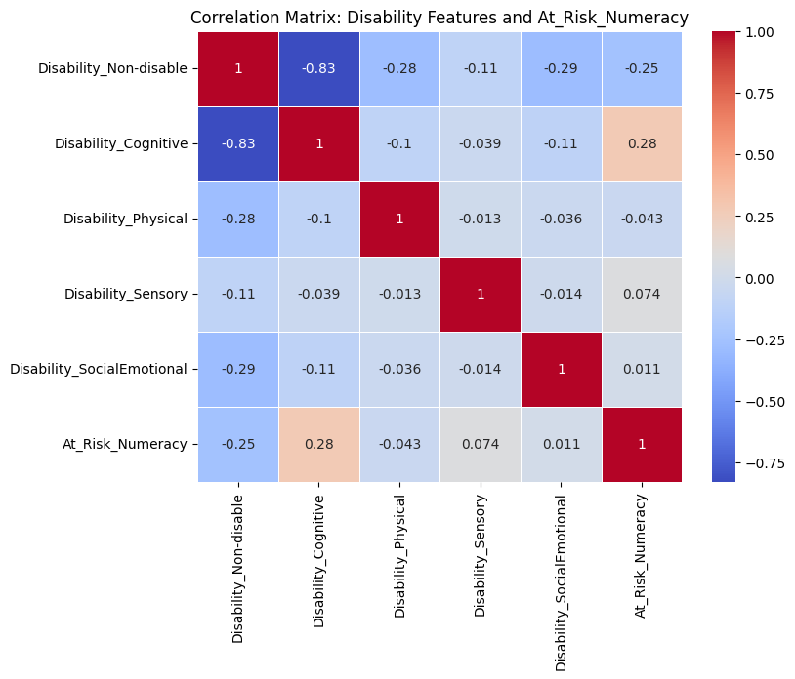

**EDA:**  
• Cognitive Disability shows mild positive correlation with risk (r = 0.28).  
• Non-disabled status has a mild negative correlation (r = -0.25).

**Insights:**  
• Cognitive disability is the most relevant predictor of numeracy risk.

***Model Development***

***Supervised Model***

***Logistic Regression***

Logistic regression is a supervised machine learning model used to predict outcomes with two possible categories—such as success/failure. Being supervised means the model learns from labelled data where the correct outcomes are known, allowing it to identify patterns and relationships. It’s widely used because it helps identify which factors influence the outcome**(Azodi, Tang, & Shiu, 2020).**

We chose logistic regression because it predicts which students are at risk of numeracy difficulties and identifies key numeracy and literacy skills contributing to this risk. With 75% of students classified as at risk, this helps us better understand and support those needing extra help.

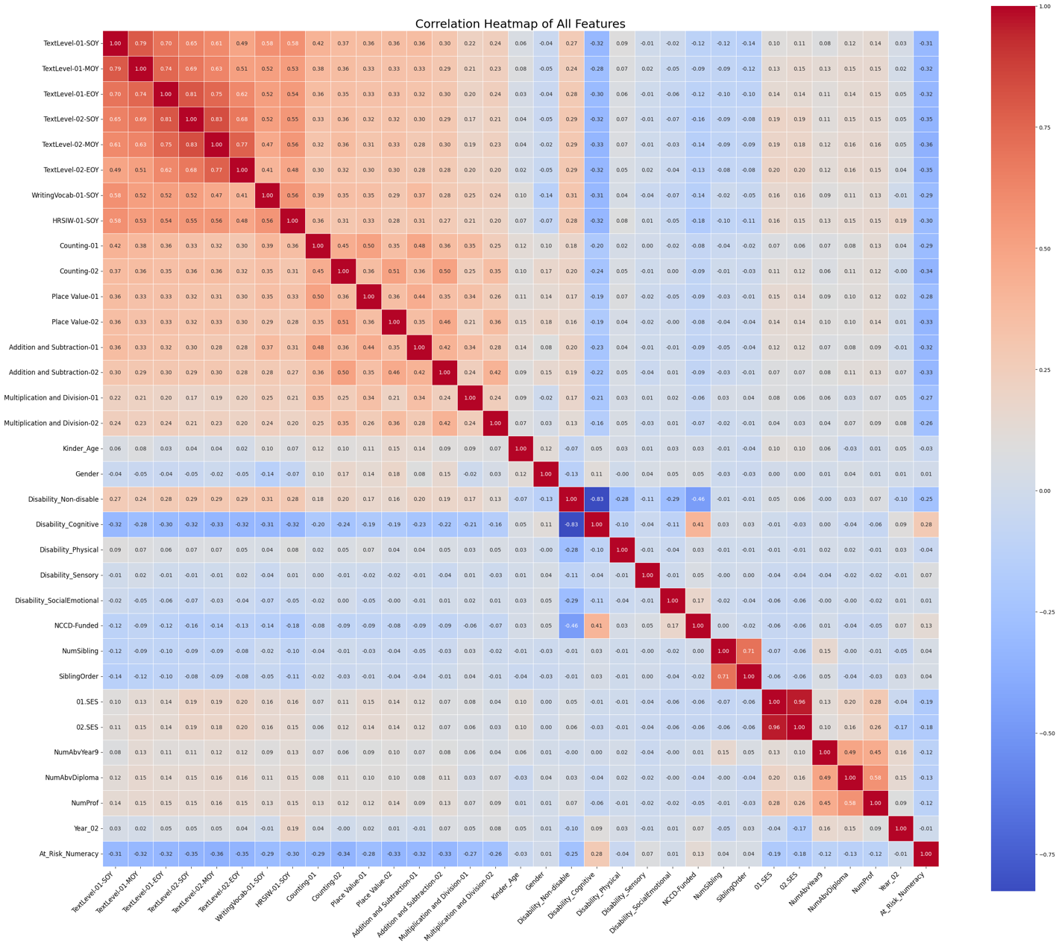

***Feature-Selection***

These features have been selected based on their negative correlation to numeracy risk, meaning that as students improve in these skills, their likelihood of being at risk of numeracy decreases

|  |  |
| --- | --- |
| Skill Area | Correlation To Numeracy |
| Text level mid-year (MOY) | -0.36 |
| Text level end of year (EOY) | -0.35 |
| Text level start of year (SOY) | -0.35 |
| Counting skills (Year 2) | -0.34 |
| Place value (Year 2) | -0.33 |
| Addition & subtraction (Year 2) | -0.33 |
| Addition & subtraction (Year 1) | -0.32 |

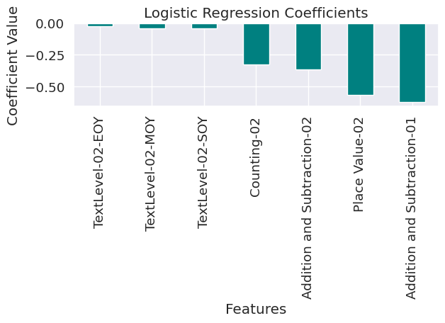

|  |  |  |
| --- | --- | --- |
| Feature | Coefficient | Interpretation of risk reduction |
| Intercept | 4.630 | (Base risk level when all features = 0) |
| Place Value - 02 | -0.567 | (Strongest risk) |
| Addition & Subtraction - 02 | -0.365 | (Moderate risk ) |
| Counting - 02 | -0.326 | (Moderate risk) |
| Text Literacy Levels (SOY, MOY, EOY) | -0.043 to -0.026 | (Smaller risk) |

***Data Preparation and Splitting***

* The data was split 75% for training and 25% for testing to let the model learn well and fairly evaluate performance on new data.
* The logistic regression model was trained on scaled features to predict student risk, comparing predicted labels and probabilities with actual outcomes to evaluate performance.

***Performance Metrics***

* **Accuracy (81%)**: The model correctly predicts student risk about 81% of the time, but this doesn’t fully show how well it identifies struggling students.
* **Precision (70%)**: When the model identifies a student as at risk, it’s correct 70% of the time, though some students may be falsely flagged.
* **Recall (36%)**: The model detects only 36% of students who truly need help, missing many who may require support.
* **F1 Score (48%)**: Balancing precision and recall, the score shows room for improvement in catching at-risk students without many false alarms.

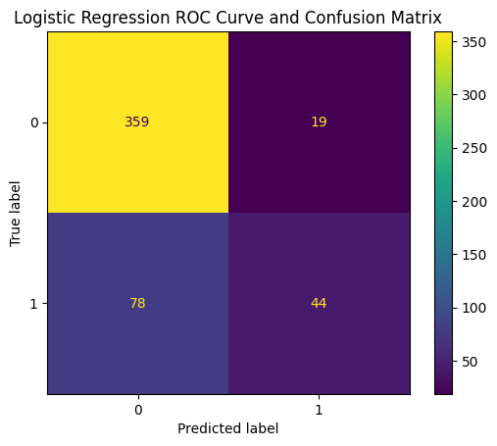

The confusion matrix shows how well the model predicts student risk:

* **359 students** were correctly identified as not at risk.
* **19 students** were wrongly flagged as at risk (false alarms).
* **44 students** were correctly identified as at risk.
* **78 students** at risk were missed by the model.

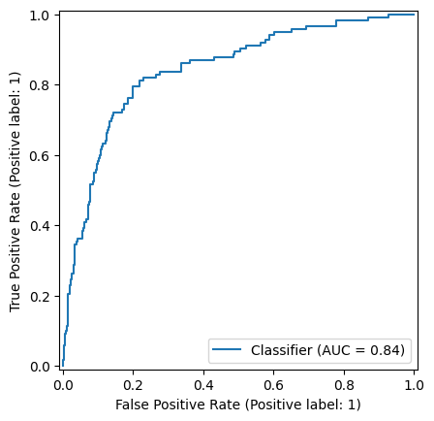

***AUC curve***

The AUC of 0.84 indicates our model has good ability to identify between not-at-risk and at-risk students. An AUC near 1 shows excellent prediction, so 0.84 means the model performs well overall. This demonstrates early literacy and numeracy skills effectively identify students at risk of numeracy difficulties.

***Sigmoid Curve***

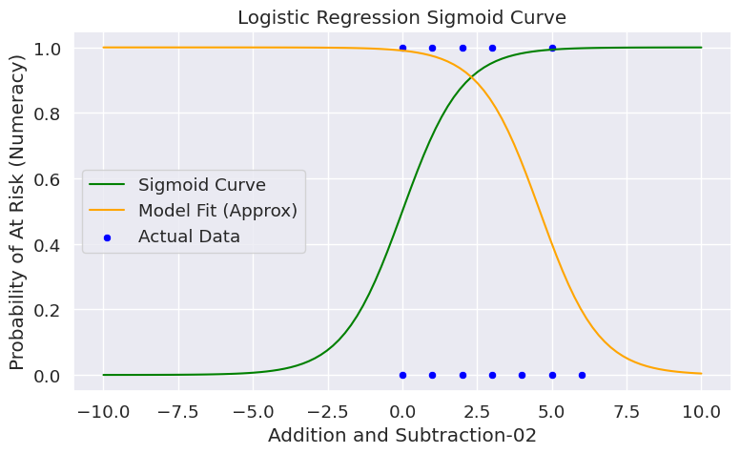

* Students scoring low (0-2) in “Addition and Subtraction-02” have a high risk of numeracy difficulties.
* As scores rise above 5, the risk drops to nearly zero.
* This highlights how early addition and subtraction skills help identify students needing support.

***K-Nearest Neighbours (KNN)***

K-Nearest Neighbours (KNN) is a simple supervised machine learning method that classifies data points based on the labels of their closest ‘k’ neighbours.

KNN is used to predict which students might be at risk of numeracy difficulties by comparing their early literacy and numeracy skills to those of similar students. This helps identify at-risk students based on their proximity to peers with known outcomes**(Slade, Prinsloo, & Khalil, 2019).**

their early literacy and numeracy skills with those of similar students

***Testing Different k Values and Their Impact***

* Testing different k values showed that k=10 had 80% accuracy but low recall (34%), missing many at-risk students.
* At k=30, accuracy improved to 81% with recall rising to 38%, but still missing many.
* The optimized k=13 balanced accuracy (81.8%), precision (69%), and recall (47%) best, improving F1-score (56%) and enabling schools to target support more effectively

***Performance Metrics***

The final model achieved an F1 score of approximately 0.47 with the best threshold set at 24%

* **Accuracy:** The model correctly classifies about 77% of students as either at risk or not at risk.
* **Precision:** When the model predicts numeracy is at risk, it’s right about 52% of the time. This means some students are flagged incorrectly, but this trade-off is acceptable to ensure we don’t miss too many at-risk students.
* **Recall:** The model identifies 77% of actual at-risk students, which is crucial for early intervention, as most students needing support are caught early.
* **F1 Score (~0.62):** This shows a good balance between precision and recall, focusing on accurately identifying students who may struggle with numeracy and literacy.

***Cross-Validation***

Using 10-fold and Leave-One-Out method, the model’s accuracy consistently ranged between 77-79%, demonstrating its reliability for predicting new student data.

***ROC Curve and Confusion Matrix Interpretation***

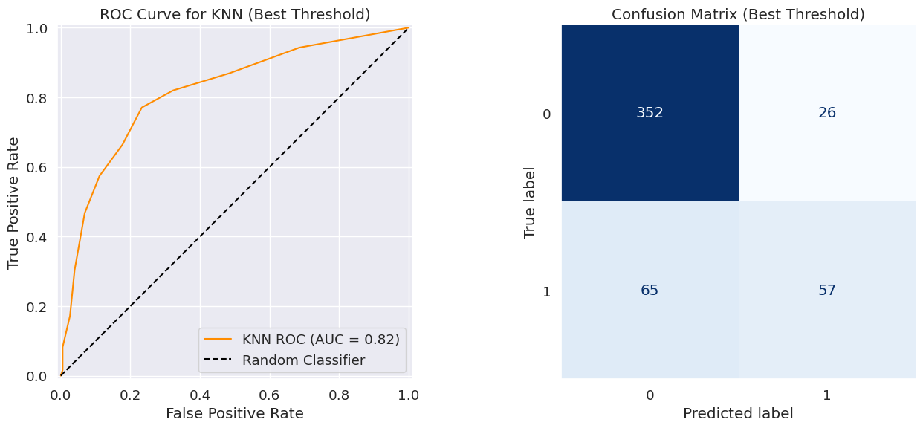

* The model distinguishes well between at-risk and not at-risk students, AUC of 0.82 pin-point strong predictive power.
* Confusion matrix at the best threshold The model correctly recognizes 57 at-risk students and missed 65 at-risk students.

***Unsupervised Model***

***K-means Clustering***  
Clustering is an unsupervised machine learning that cluster data points based on their resemblance without using predefined labels. It helps uncover natural patterns or segments within data. In the context of my study, clustering helps identify distinct groups of students based on their early literacy and numeracy skills, enabling tailored educational support for different learning profiles(**Strickland, Woods, & Pavlovic, 2016).**

***Feature Selection Using Mutual Information Score (MIS)***

Mutual Information Score (MIS) is used to select features most related to numeracy risk. The top features were TextLevel-02-SOY (0.0757) and TextLevel-02-EOY (0.0457), showing they best capture the risk information for effective student clustering

***Data Exploration with KDE Plots***

Kernel-Density-Estimation plots show At-risk students consistently have lower literacy scores at both start and end of year, confirming these features effectively analyse risk profiles.

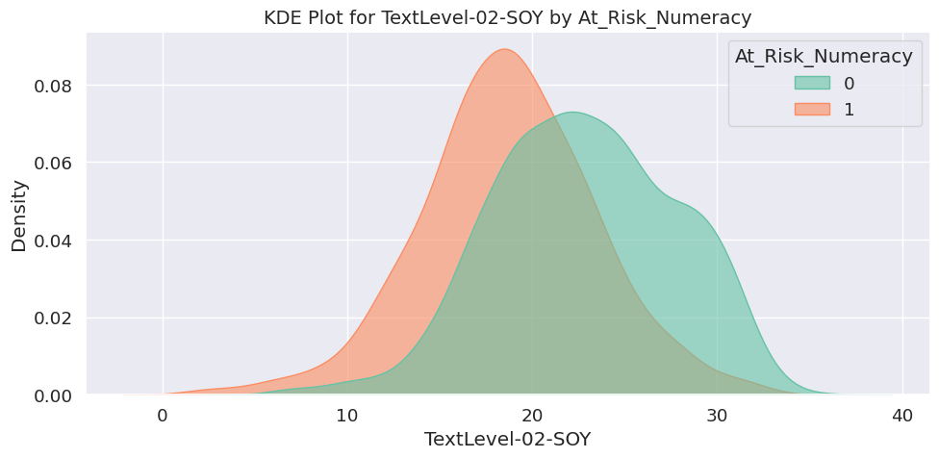

Figure 29

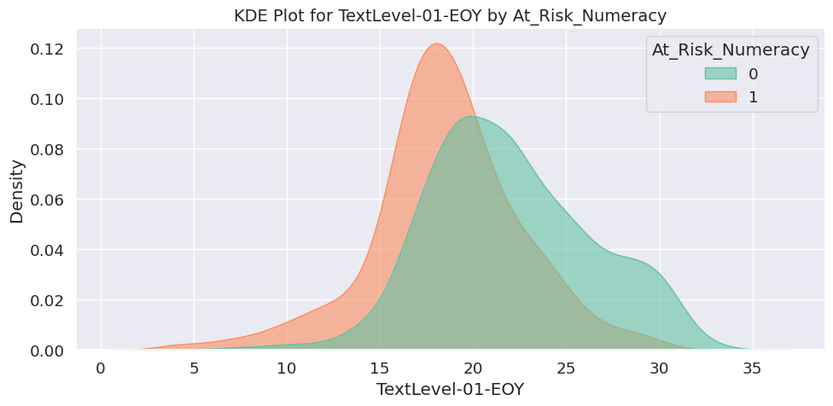

Figure 30

***Clustering with k without optimising***

K-Means clustering with k=4 was chosen randomly where the metric values are:

* WCSS = 18.979 indicates reasonably compact clusters.
* DBI = 0.795 (below 1) shows good cluster separation.
* Silhouette Score = 0.401 suggests moderate cluster definition with some overlap.

***Silhouette Plot Interpretation***

An average score of 0.401 suggests the clusters are reasonably distinct and meaningful, making the four groups useful for understanding and supporting different student needs.

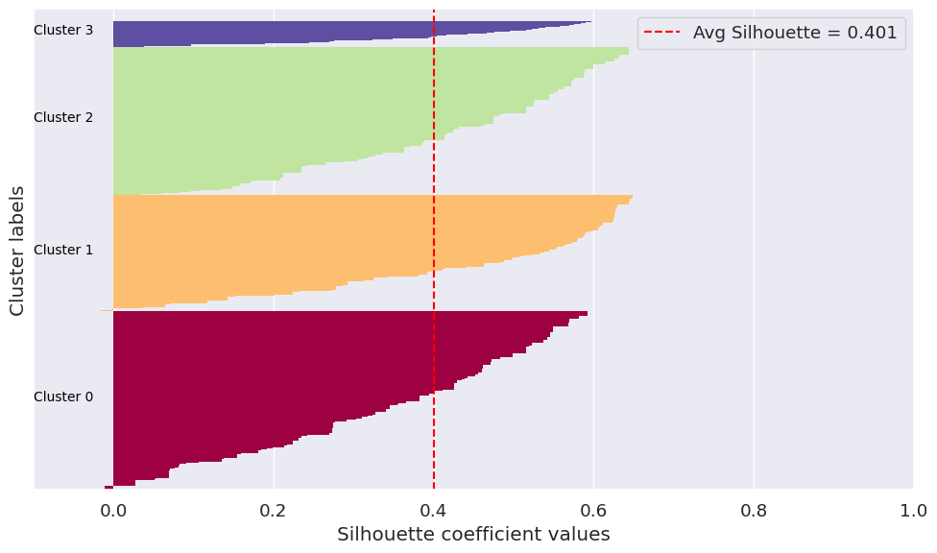

***K Optimization With these metrics***

* Elbow Method (SSE): Measures cluster compactness; sharp drop then flattening at k=4-6 suggests optimal range. Very low SSE at k=40 may cause overfitting.

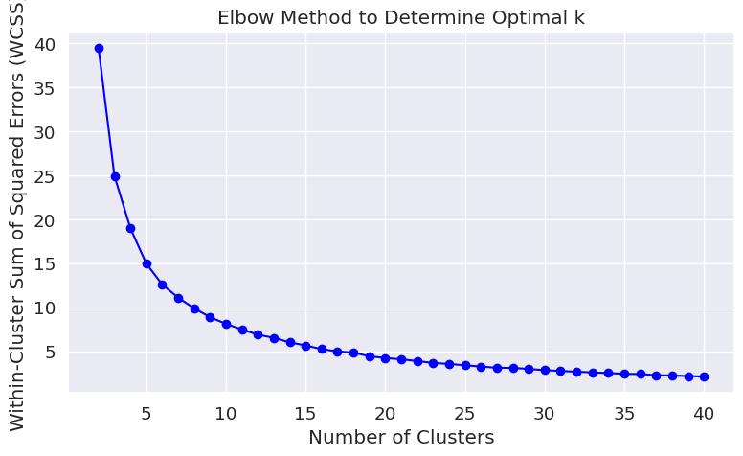

* Davies-Bouldin Index (DBI): Measures cluster separation; best DBI of 0.719 at k=2 indicates good, distinct clusters.

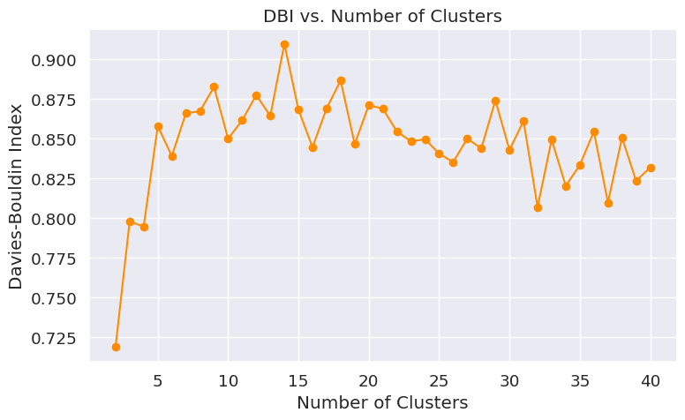

* Silhouette Score: Measures cluster fit; best score 0.492 at k=2 shows moderate quality with room for improvement.

***Model Evaluation with Best K***

After optimizing, the best k was found to be **2** , with the following evaluation metrics:

* **Within-Cluster Sum of Squares (WCSS): 39.479** — indicates reasonable compactness of the clusters.
* **Davies-Bouldin Index (DBI): 0.719** — suggests good separation and cohesion between clusters, as lower values indicate better clustering quality.
* **Silhouette Score: 0.492** — indicates moderate clustering strength, meaning the clusters are reasonably well-defined but some overlap exists.

***Silhouette Plot for K = 2***

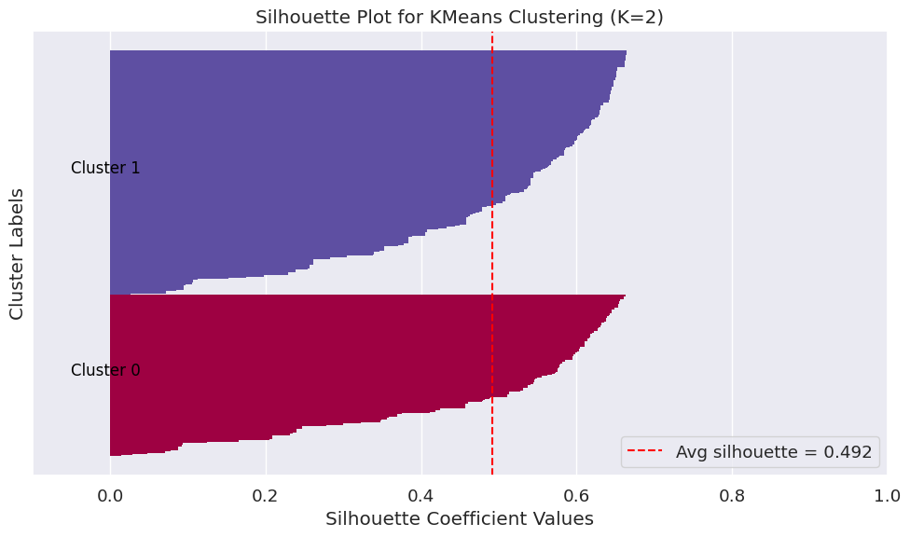

* Silhouette Plot for K=2 shows silhouette values for each data point.
* The average score of 0.492 indicates good cluster separation.
* Most points score above 0.4, confirming distinct, well-defined clusters.

***Cluster Distribution Pie Chart***

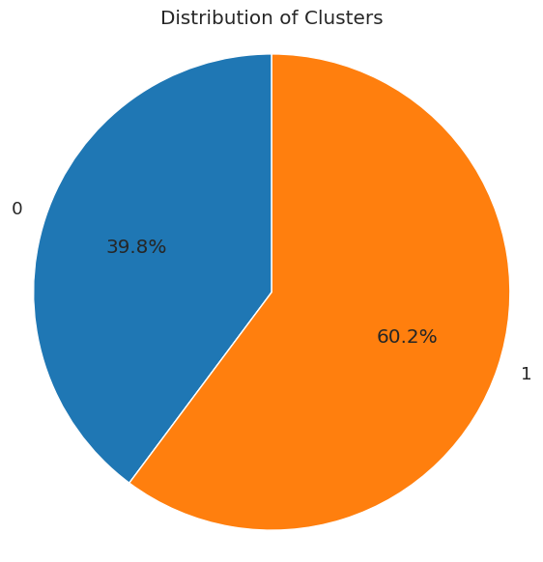

This pie chart shows that Cluster 0 has about 40% of students and Cluster 1 has 60%, indicating a natural split into two groups based on literacy scores.

***Centroid (TextLevel-02-SOY vs TextLevel-01-EOY)***

* The centroids represent average literacy levels for each cluster.
* Cluster 0 centroid shows higher start- and end-of-year literacy scores, indicating stronger skills.
* Cluster 1 centroid has lower literacy scores, indicating weaker skills.
* Clear separation of centroids shows two distinct student groups with different literacy progress

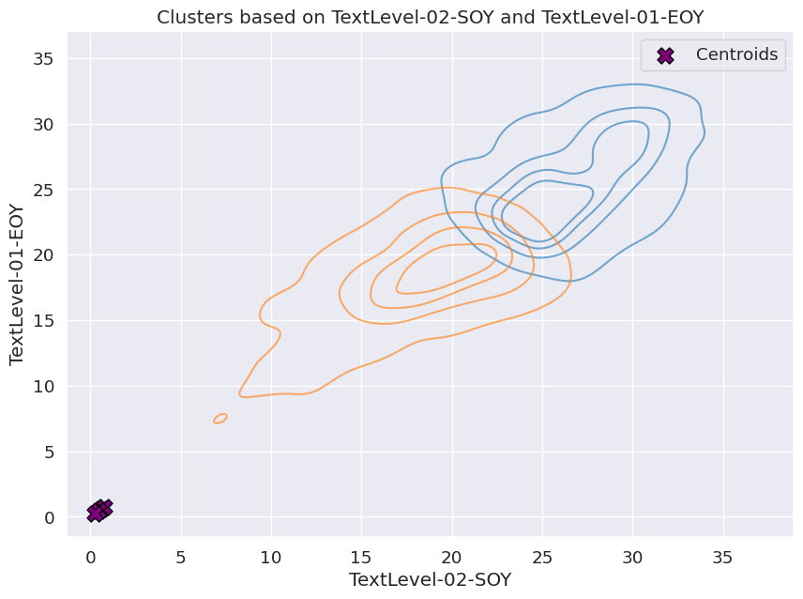

***3D Scatter Plot with At_Risk_Numeracy (All Clusters*)**

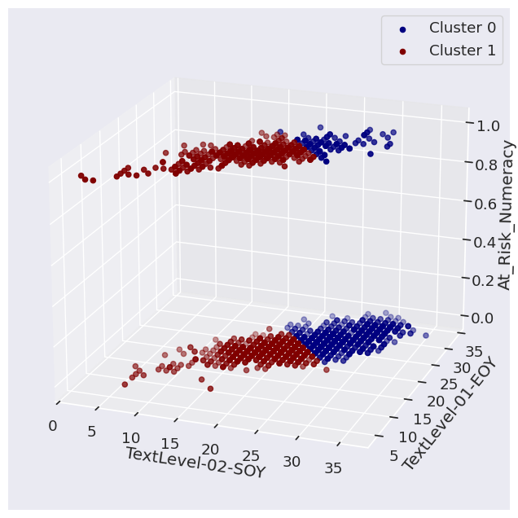

Figure 37

* The 3D scatter plot shows clusters based on literacy scores and risk status.
* Cluster 1 has students with low literacy and high numeracy risk
* Cluster 0 has higher literacy and lower risk.

***3D Scatter Plot for Cluster 0***

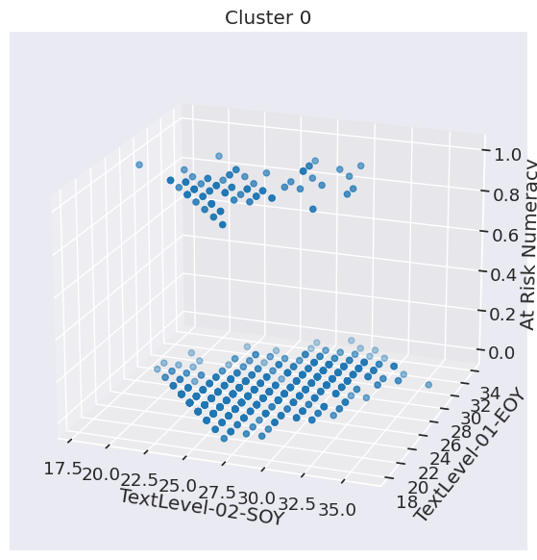

* Shows only data points in Cluster 0, mostly students with higher literacy scores and mostly not at risk.
* These students are grouped tightly, indicating good cluster cohesion.

***3D Scatter Plot for Cluster 1***

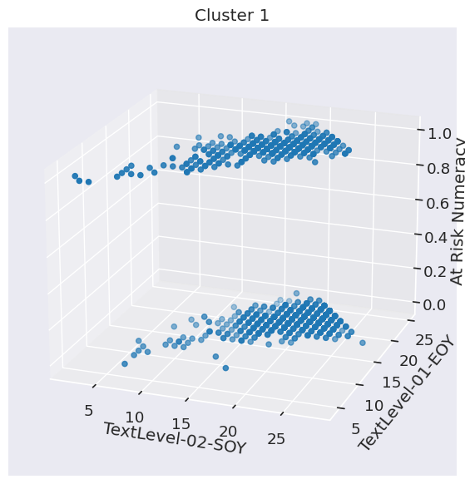

* Shows data points in Cluster 1, mostly students with lower literacy scores and a high proportion of at-risk students.
* This group represents the students needing more attention/intervention.

**Correlation Matrix Cluster Map**

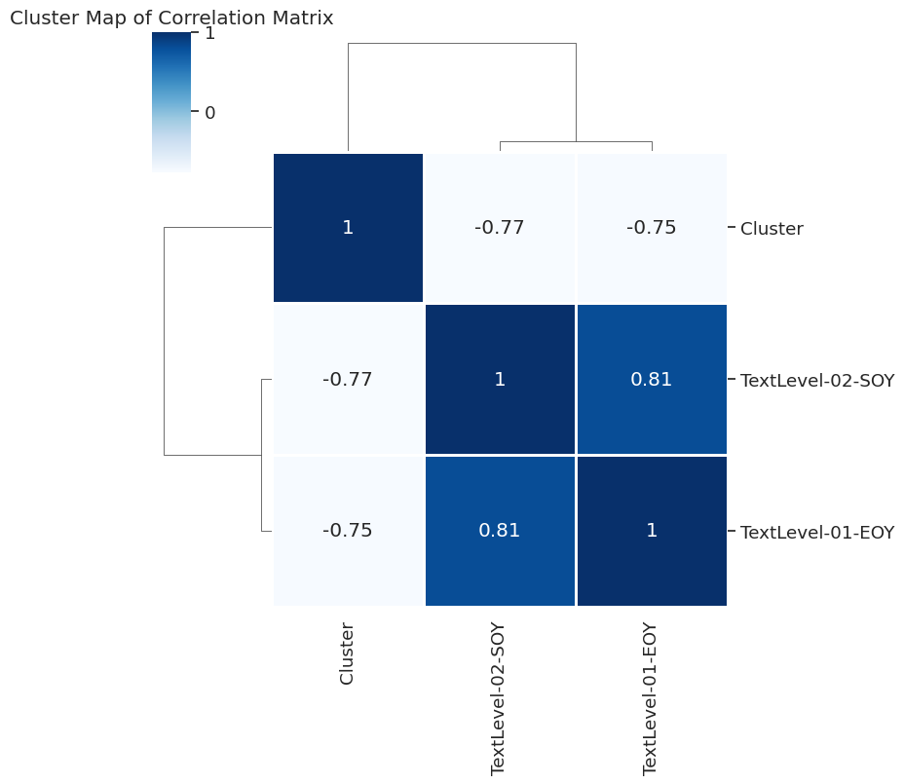

* This heatmap shows a strong positive correlation (0.81) between TextLevel-02-SOY and TextLevel-01-EOY, indicating steady literacy progress.
* There is a -0.75 to -0.77 correlation between clusters and these features, meaning students in Cluster 1 have lower literacy scores and higher risk.

***Interpretation and Discussion of Results***

***Supervised Models (Logistic Regression vs KNN)***

|  |  |  |  |  |
| --- | --- | --- | --- | --- |
| Selection Metric | Logistic Regression | K-Nearest Neighbours (KNN) | Which is Better? | Explanation |
| Accuracy | 81% | 77% | Logistic Regression | Logistic Regression is better overall at correctly classifying students. |
| Precision (At Risk) | 70% | 52% | Logistic Regression | Logistic Regression is more precise, with fewer false positives. |
| Recall (At Risk) | 36% | 77% | KNN | KNN detects more actual at-risk students, critical for early intervention. |
| F1-Score (At Risk) | 48% | 62% | KNN | KNN balances precision and recall better for at-risk students. |
| AUC | 0.84 | 0.82 | Logistic Regression | Logistic Regression has a slightly higher AUC, indicating stronger overall performance. |

***Unsupervised Model***

* Clustering split students into two clear groups based on literacy and risk levels, helping to tailor support. With a decent Silhouette Score of 0.49 and a low Davies-Bouldin Index of 0.72, the clusters are well-formed and distinct. The compactness shown by WCSS (39.48) means students in each group are similar. Overall, clustering does a good job identifying meaningful student groups for targeted help.

Logistic Regression balances accuracy and precision well, reliably identifying at-risk students with few false alarms. Clustering groups similar students to tailor support. Together, they provide clear predictions and insights for student At-Risk

***Solution Recommendation***

* To catch more students who might be missed, schools should give extra attention to “Place Value-02” skills and strengthen early support programs.
* To avoid unnecessary help, schools can have teachers double-check students flagged as at risk before taking action.
* Students struggling with addition and subtraction (scoring 0-2) should get targeted help, with regular progress check-ins.
* Data2Intel and schools should gather more info, like attendance and learning habits, to make the model better at spotting at-risk kids.
* Support should be tailored based on student groups—schools and policymakers can focus more on those at higher risk while giving extra enrichment to others.
* Teachers’ ongoing feedback can help improve how students are grouped, making support more accurate.
* Using student progress over time can keep these groups updated and ensure the help stays relevant as kids grow.

***Future Engagement***

* Adding data like family background, attendance, and behaviour will improve recall by identifying more at-risk students **(Wiliam, 2011).**
* Continuously collecting and updating student data will improve accuracy and the ROC curve by providing richer information.
* Collaborating with schools on targeted support programs and gathering feedback will improve the model’s relevance and effectiveness over time.

***Technical recommendations***

Analysis and modelling were done using Python with libraries like scikit-learn, pandas, and matplotlib/seaborn. Python was chosen for its extensive ecosystem, ease of use, strong community support, and suitability for rapid prototyping. Google Collab (version 3.111.11) provided free cloud computing, easy collaboration, and seamless Python integration without local setup. While R and Julia offer statistical and performance advantages, Python’s versatility made it the best fit for this project **(Müller & Guido, 2017).**

***Maintenance and Accuracy***

* **Regularly retrain the model with new student data** to keep up with changing learning patterns.
* **Add important new information** such as attendance, family background, and behaviour to improve prediction accuracy.
* **Work closely with teachers to get feedback** and refine the model and support programs to better help students.

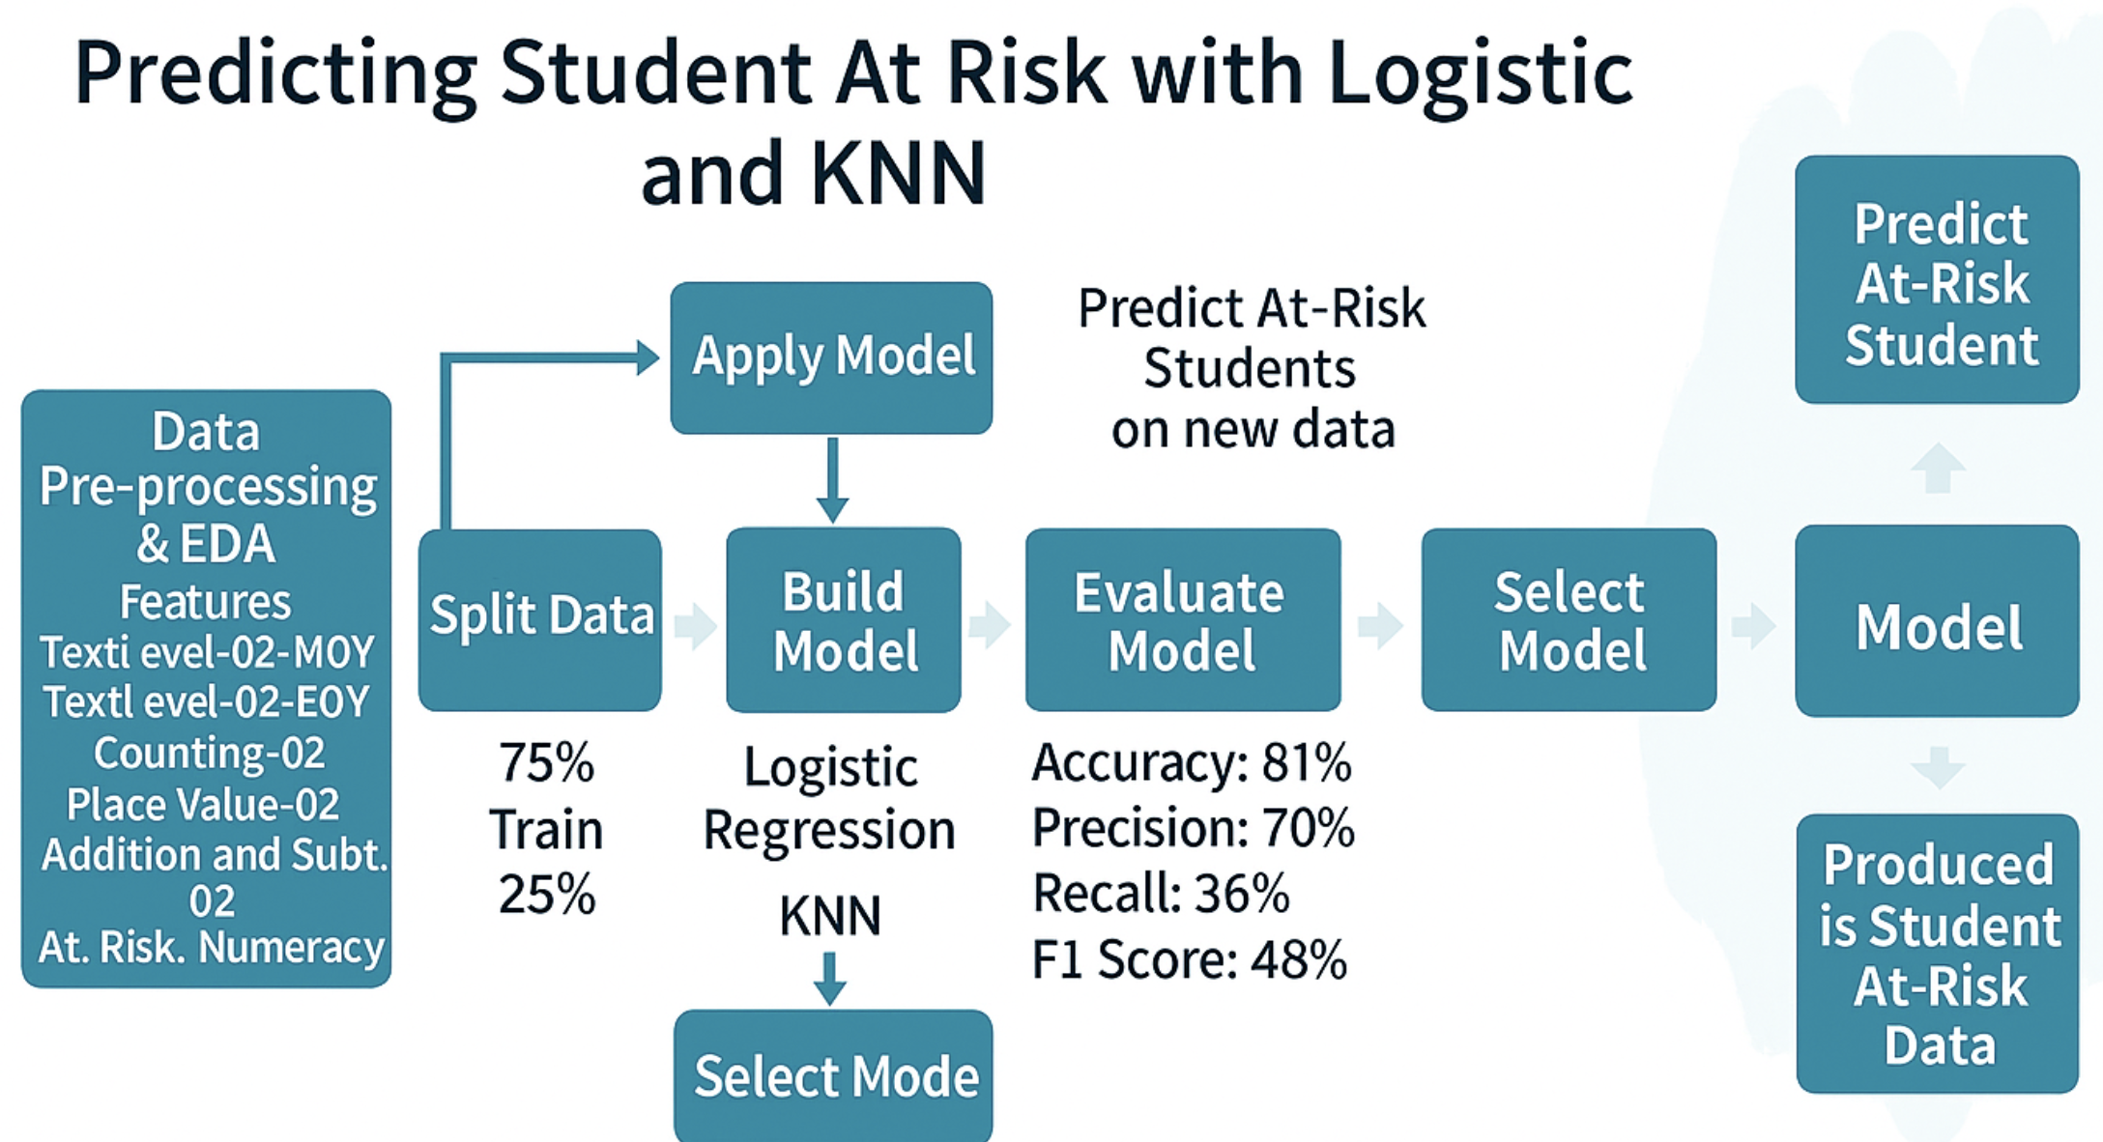

***Logistic Regression***

**Pros:**

The model is quite accurate (81%) showing clearly which skills affect student risk (**Müller & Guido, 2017).**

efficiently separating at-risk and not-at-risk students with AUC(0.84).

**Cons:**

* Low recall (36%) means many at-risk students are missed.
* Assumes linear relationships, which might not properly illustrate complex student data.

**Clustering**

***Pros:***

* Helps group students by literacy and risk profiles.
* Moderate silhouette score (0.49) indicates well-defined clusters.

***Cons:***

* Some overlap between clusters may reduce different-group clarity **(Müller & Guido, 2017**).
* Does not directly predict risk status, so less precise for classification.

***References***

• ACARA. (2020). National Assessment Program – Literacy and Numeracy (NAPLAN). <https://www.nap.edu.au>

• Azodi, C. B., Tang, J., & Shiu, S. H. (2020). Opening the black box: Interpretable machine learning for geneticists. Trends in Genetics, 36(6), 442–455. <https://www.cell.com/trends/genetics/abstract/S0168-9525(20)30069-X>

• DESE. (2021). Australian Early Development Census (AEDC): National Report 2021. <https://www.aedc.gov.au/resources/detail/2021-aedc-national-report>

• Müller, A. C., & Guido, S. (2017). Introduction to Machine Learning with Python: A Guide for Data Scientists. O’Reilly Media.

• Slade, S., Prinsloo, P., & Khalil, M. (2019). Learning analytics: Ethical issues and dilemmas. American Behavioral Scientist, 64(11), 1510–1529. <https://www.researchgate.net/publication/258122968_Learning_Analytics_Ethical_Issues_and_Dilemmas>

• Strickland, J., Woods, K., & Pavlovic, M. (2016). Assessing and understanding early numeracy for students with additional learning needs. AARE 2016 Conference. <https://www.aare.edu.au/data/2016_Conference/Full_papers/69-1_Jane_Strickland.pdf>

• Wiliam, D. (2011). Embedded formative assessment. Solution Tree Press.